REQUIREMENT ANALYSIS

Technology stack (Architecture & Stack)

|  |  |
| --- | --- |
| Date | June 2025 |
| Team ID | LTVIP2025TMID50867 |
| Project Name | ToyCraft tales: tableau's vision into toy manufacturer data |
| Maximum Marks | 4 Marks |

Technical Architecture

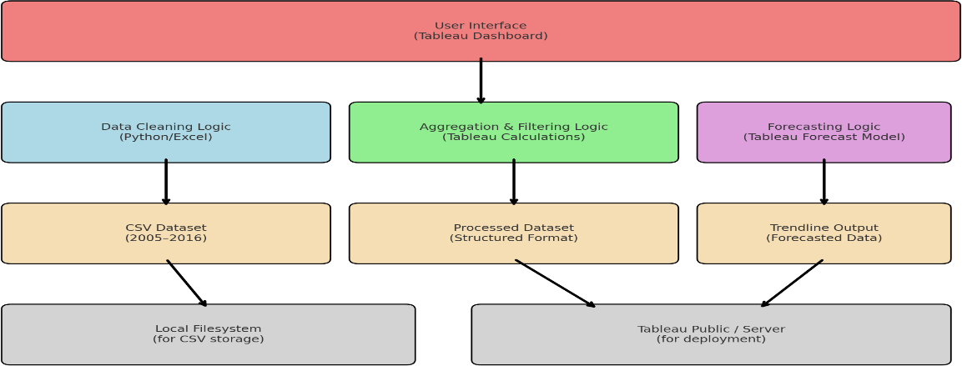

Table-1 : Components & Technologies:

|  |  |  |  |
| --- | --- | --- | --- |
| **S.No** | **Component** | **Description** | **Technology** |
| 1. | User Interface | Dashboard interface for users to interact with data | Tableau Public |
| 2. | Application Logic-1 | Data cleaning and transformation | Excel(pre-Tableau) |
| 3. | Application Logic-2 | Data aggregation by year, category, region | Tableau calculated fields |
| 4. | Application Logic-3 | Forecasting based on historical trends | Tableau Forecasting |
| 5. | Database | CSV dataset with shipment and category info | Excel sheet |
| 6. | Cloud Database | Not applicable | Tableau cloud |
| 7. | File Storage | Upload and store toy dataset | Local drives or google drive |
| 8. | External API-1 | Weather data to correlate seasonality | Open WeatherAPI |
| 9. | External API-2 | Social media trend integration | Google Trends |
| 10. | Machine Learning Model | Predictive modeling | Tableau’s built-in forecast model |
| 11. | Infrastructure (Server / Cloud) | Cloud-hosted dashboard viewable by users | Tableau Server/Tableau public |

Table-2: Application Characteristics:

|  |  |  |  |
| --- | --- | --- | --- |
| **S.No** | **Characteristics** | **Description** | **Technology** |
| 1. | Open-Source Frameworks | Python (data cleaning) | Python |
| 2. | Security  Implementations | Restricted access via Tableau login | IAM (Tableau server) |
| 3. | Scalable Architecture | Tableau scales to multiple dashboards/users without code changes | Tableau cloud Architecture |
| 4. | Availability | Dashboard hosted on Tableau Public with 24/7 access | Tableau server/Tableau public |
| 5. | Performance | Optimized visual queries, aggregated filters, and trendline calculations | Tableau filtering |